**BackBase Test Automation instruction for Computer Database**

***Test*** *Automation tool and framework*: Selenium Webdriver, data & object driven framework with Java programming & Junit annotations developed in Eclipse IDE.

To run the automation test scripts you would need to download:

* the latest Java libraries: <https://www.oracle.com/technetwork/java/javase/downloads/jdk11-downloads-5066655.html>
* Eclipse IDE: <https://www.eclipse.org/downloads/> (or your preferred IDE)
* Selenium Webdriver jar files: https://www.seleniumhq.org/download/
* Chrome Webdriver executable.

On successfully downloading the above;

* Run the Eclipse executable to open Eclipse.
* Create an Eclispse workspace
* Create a Java Project within your Eclipse Workspace.
* Import your Selenium Webdriver and Java jars into your Java project within Eclipse( in this case simple import the project provided for the CRUD test automation for <http://computer-database.herokuapp.com/computers> web app).

To run the test scripts you may either open or and right click on the java class file “CRUD” and click on Run As --> JUnit Test.

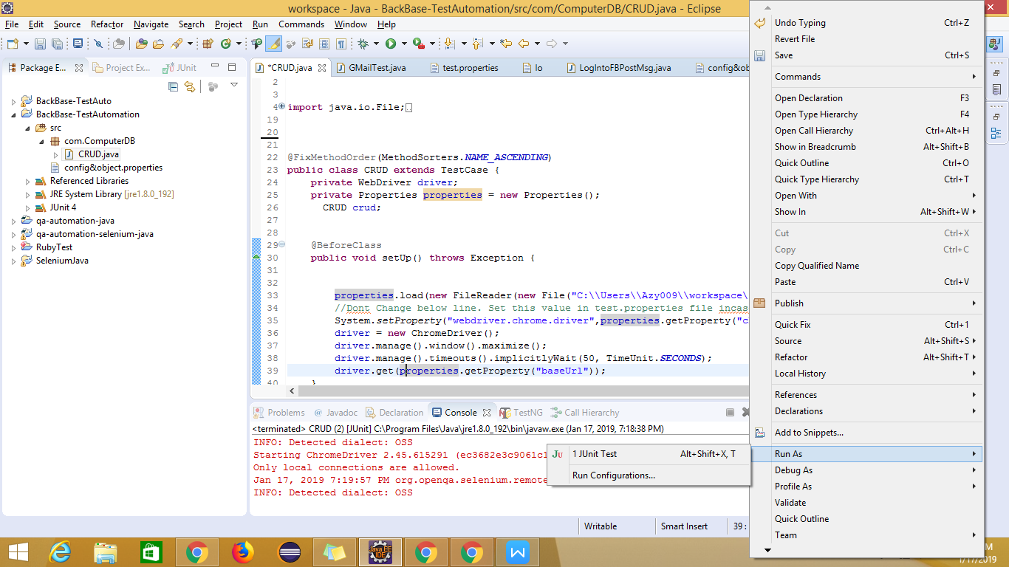

The automated process of running the scripts will kick off, on completion.

You can view the test result and error(s)/failure(s),as applicable. Thus you can evaluate and trace the errors. See image below:

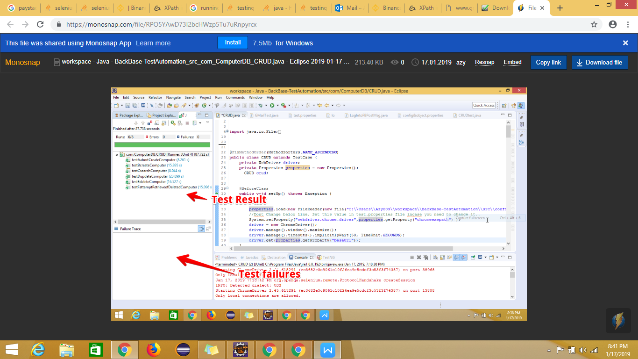

Please, do note that you can run an individual test case independent of the whole test suite, should you have the need to. This can be done by highlighting the method of target test case, right-click and click on “Run As”menu ---> JUnit Test, which would kick off the automation of the selected test case.

Also, be informed that this is data driven frame work, with a data and object file “*config&object.properties*” where you can enter/update your data input and element objects. Thus the said file serves as both an data and object repository. See image below:

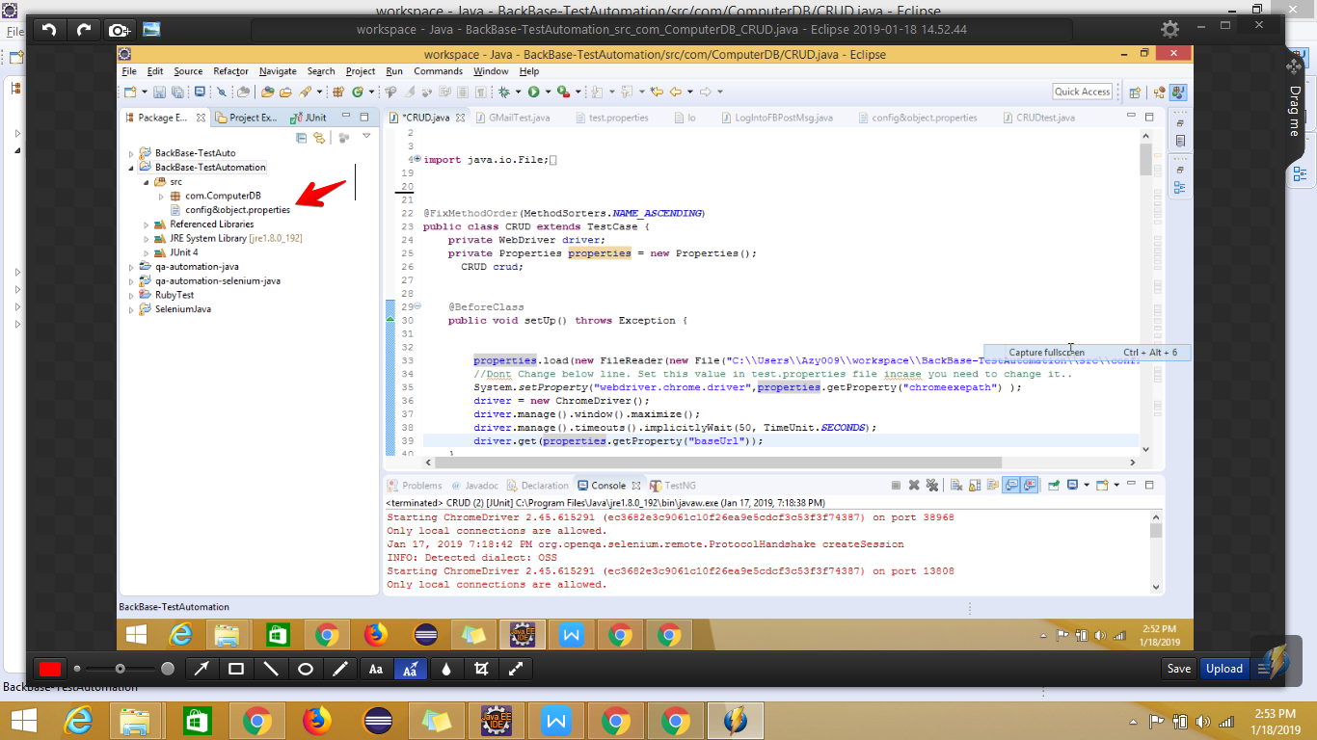

Happy test automation running!

You may reach me at [azbaba@hotmail.co.uk,](mailto:azbaba@hotmail.co.uk,) if clarification is required.